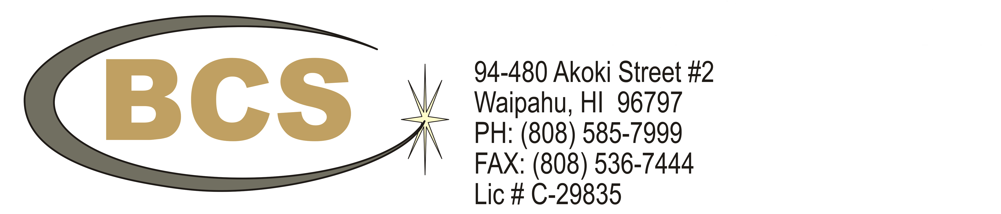

**Telecommunications Contractor**

Date: `DATE~

Project: `SHORT~

BCS service offers installation of commercial and industrial grade cabling solutions. BCS installations include inside plant cabling of Category 5e/6, fiber optics, coaxial, security and control cabling. BCS also provides outside plant cabling for high pair copper, fiber optics, and coaxial. All projects are supported by a Registered Certified Distribution Designer (BICSI, RCDD) and Certified BICSI Installers to ensure strict adherence to industry standards and a successful design and construction team.

PROJECTS:

**MV-22 Hanger & Infrastructure**

Customer Name: NAVFAC Pacific

Customer Address: Marine Corps Base Hawaii

Reference Name: Van Stottlemyer

Current Phone #: 808-257-2876

Description of Work Performed:

Provision and installation of approximately 111,000 feet of Category 6 cable serving 250 outlets. Provision and installation of 12 strand fiber optic horizontal and backbone cable. Completed 2016.

**UH Campus Upgrade – Saunders Hall**

Customer Name: The University of Hawaii at Manoa

Customer Address: 2500 Campus Road, Honolulu, HI 96822

Reference Name: Carl Yoshioka

Current Phone #: 808-956-6659

Description of Work Performed:

Provision and installation of approximately 300,000 feet of Category 6 cable serving 500 outlets. Completed August 2015.

**UH Information Technology Center**

Customer Name: The University of Hawaii at Manoa

Customer Address: 2500 Campus Road, Honolulu, HI 96822

Reference Name: Carl Yoshioka

Current Phone #: 808-956-6659

Description of Work Performed:

Provision and installation of approximately 800,000 feet of Category 6A cable serving 3,000 outlets. Provision and installation of approximately 27,000 feet of MM Fiber Optic Cable. Completed September 2014.

**UH Cancer Research Center**

Customer Name: The University of Hawaii at Manoa

Customer Address: 2500 Campus Road, Honolulu, HI 96822

Reference Name: Carl Yoshioka

Current Phone #: 808-956-6659

Description of Work Performed:

Provision and installation of approximately 600,000 feet of Category 6 cable serving 1,000 outlets. Completed January 2014.

**Queen’s Medical Center – West Campus**

Customer Name: The Queens Foundation

Customer Address: 91-2141 Fort Weaver Rd, Ewa Beach, HI 96706

Reference Name: Ramunas Savickas

Current Phone #: 808-691-3010

Description of Work Performed:

Provision and installation of approximately 800,000 feet of Category 6 cable serving 1000 outlets. Provision and installation of 48 and 96 strand fiber optic horizontal and backbone cable. Completed 2014.

**Queen’s Medical Center – West Campus**

Customer Name: The Queens Foundation

Customer Address: 91-2141 Fort Weaver Rd, Ewa Beach, HI 96706

Reference Name: Ramunas Savickas

Current Phone #: 808-691-3010

Description of Work Performed:

Provision and installation of approximately 800,000 feet of Category 6 cable serving 1000 outlets. Provision and installation of 48 and 96 strand fiber optic horizontal and backbone cable. Completed 2014.

**NOAA Inouye Regional Center**

Customer Name: US Department of Commerce

Customer Address: 1845 Wasp Blvd, Honolulu, HI 96818

Current Phone #: (808) 725-5360

Description of Work Performed:

Provision and installation of approximately 2,000,000 feet of Category 6A cable serving 2,000 outlets. Provision and installation of 4, 12, 24, 48, 96 and 144, strand fiber optic horizontal and backbone cable. Completed 2013.

**Hawaiian Airlines Corporate Offices**

Customer Name: Hawaiian Airlines

Customer Address: 3375 Koapaka St G-350, Honolulu, HI 96819

Reference Name: Michael Huo

Current Phone #: 808-233-3909

Description of Work Performed:

Provision and installation of approximately 265,000 feet of Category 6 cable serving 1,000 outlets. Provision and installation of 24 and 48 strand fiber optic horizontal and backbone cable. Completed 2013.

**Disney Aulani Resort**

Customer Name: Disney

Customer Address: 92-1185 Ali'inui Dr, Kapolei, HI 96707

Reference Name: Kealoha Kon

Current Phone #: 808-216-8232

Description of Work Performed:

Provision and installation of approximately 1,000,000 feet of Category 5e cable serving 3000 outlets. Provision and installation of 48, 96 and 144 strand fiber optic backbone cable. Completed 2011.

**Kaiser Ancillary Renovation**

Customer Name: Kaiser Permanente

Customer Address: 3288 Moanalua Rd, Honolulu, HI 96819

Reference Name: Jill Blaisdell

Current Phone #: 808-216-6147

Description of Work Performed:

Provision and installation of approximately 927,000 feet of Category 5e cable serving 800 outlets. Provision and installation of 48 strand fiber optic horizontal and backbone cable. Completed October 2012.